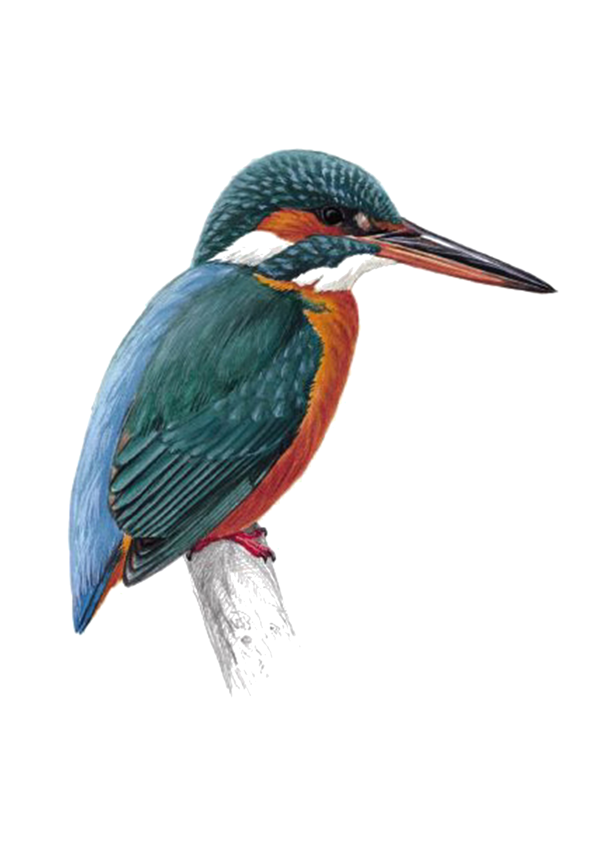
Fledglings Festival

Solo entry form for (School): ……………………………………………………………..

Sections: Baby: age 2-5 A: age 6+7 B: age 8+9 C: age 10+11 D: age 12+13 E: age 14+

NAME | Age at Comp | Tap | Ballet | Modern | Lyrical | Song & Dance | Acro | Total Fee  £6 per dance

Page Total: ______

